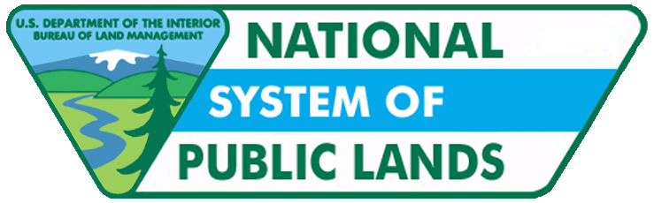
Bureau of Land Management
2009
Three-Mile Method
With Belle Craig

Cadastral Survey

Three-Mile Method
Now that we have seen how this edition of the Manual was developed, let’s look at a few specific topics. First, a special method of section subdivision known as the three-mile method was historically used by the General Land Office on certain lands. Many in the private sector have asked BLM to include instruction on this topic. Belle Craig will discuss how this edition of the Manual addresses this unique method.

Hi, I am Belle Craig with the BLM Cadastral Survey. I am a cadastral surveyor with the Idaho State Office. I have been working for the Bureau of Land Management since 1992, but I have been working in the surveying profession since 1981.

We are going to talk about subdivision of sections using the three-mile method. This is covered in Chapter 10 under Special Surveys. To fully understand the three-mile method outlined in this Manual, I think it is important that you actually read several sections. The first is the section on Indian Allotment Surveys. This is the first time a Manual has addressed Indian Allotments Surveys, but this Manual really does a good job of elaborating on the subject matter. The second section is the section on the Subdivision of Sections using the three-mile method. This is a new section in the Manual. Another new section in the Manual is Indian Allotment and United States Indian Service Surveys. I really recommend that you would read these so that you understand this three-mile method of subdividing sections in context.

The reason why we are talking about this today is most of us are used to this thinking about subdivision of sections in terms of using statutory method where the law and GLO instruction tell us to subdivide regular sections by intersecting the north-south and east-west centerlines. For instance, establishing the center quarter it would be at intersection. From about 1868 to 1887, GLO instructions to surveyors call for using this three-mile method of subdivision for Indian Allotment Surveys. They actually had a means to do this through 43 USC 770. This provides for departures from typical survey methods used in the system of rectangular surveys.

Of course you have to have a reason to depart, from using the statutory methods of section subdivision and the reason they had was it was more economical because they could subdivide a section, chaining a lot less line. This edition also makes the point that Indian Allotment Surveys and Reservation surveys are not the same. An Indian Allotment is a parcel or parcels of land created off reservation or on it usually titled to an individual Indian. Let us see what the Manual has to say about the three-mile method of section subdivision.

The manual says in its simplest and most common form. Three-mile method sections were subdivided typically by establishing the north and south one-sixteenth section corners on the east and west boundaries of the section at midpoint between the quarter corners and section corners. I am going to show you a diagram of this. Then after the sixteenth corners were established, they ran lines, the east-west center line of the section, they ran from the east boundary of the section to the west boundary and they would be setting sixteenth corners along way as they went.

This is a diagram of the three-mile subdivision used to create 40-acre allotments. Here is a 20-acre allotment example where they used the three-mile method. You can see that we have created a lot more parcels but again we are still only running those three-miles of line east and west through this section. The Manual also says that the "three-mile method" actually encompasses a variety of systems of section subdivision...there is no single three-mile method. The evidence, field conditions, and historical documents of the section subdivision must be carefully examined to determine which method was used.

I actually have a pretty interesting example from the White Earth reservation. This was a resurvey by a man named William Ward and I would like to call your attention to the fact that we have distances returned on sixteenth lines in section 5 and those lines run east and west. And we also have distances returned on sixteenth lines in section 6, but those lines have been surveyed in a north-south fashion. We have an example of the same township where two different methods have been used to survey this three-mile method.

Surveyors working with Indian lands, on or off -reservation, and private lands outside diminished or terminated reservations must be aware of the "three-mile method" of section subdivision. Sometimes these sections are located in areas not thought to be near Indian lands. The three-mile method was used by the GLO and the USIS, now the BIA, in subdividing sections.

Let us talk about this a little bit where were these surveys done? Well there is one example near Grand Junction Colorado. When they ran the UTE Meridian, several townships in and around the valley there in Grand Junction have actually been subdivided using this three-mile method. The intent was originally to do these allotment surveys and then settle the Indians on the allotments.

The settlement of the Indians never occurred, so we had all of these townships where the three-mile method had been used to subdivide the sections and no Indians actually ever settled there. The result was is that patents were issued off the three-mile method surveys in the Grand Junction area to non-Indians.

The surveyor must always study the survey plat and field notes thoroughly to determine how the allotments were surveyed. Where the official survey used the three-mile method, perform a dependent resurvey according to the official survey record. When we talk about restoring corners along those east-west lines and we know that the center quarter was not established in intersection the proper way to restore a center quarter would be by single proportionate measurement.

Let us see what the Manual has to say about this. Recovered original corners shall stand as the corners of the patented lands and shall control the boundaries within the section regardless of how well the position fits the original plat position or the statutory method of subdividing a section.

So in summary, what I would like to say is first talk about where does the three-mile method apply? Well we just talked about an example where a three-mile method was used as 100 miles from the nearest Indian reservation. The three-mile method applies where the record indicates. I would like to caution you. This discussion today is not about some new fangled method to subdivide sections. This topic is about the Manual giving us clear instructions on how to deal with the three-mile method of survey when doing resurveys. Be sure to consult with local surveyors in your area and the BLM cadastral survey office for more historical information and guidance on this subject.

